**Count Digits**

Given a number N, the task is to return the count of digits in this number.

**Example:**

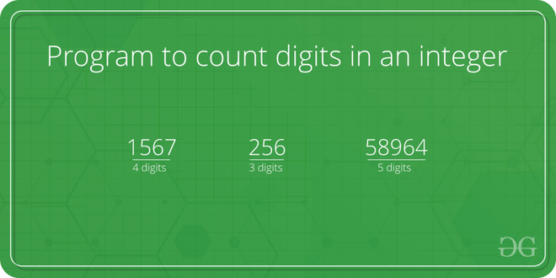

*Program to count digits in an integer*

**Simple Iterative Solution to count digits in an integer**

The integer entered by the user is stored in the variable n. Then the while loop is iterated until the test expression n != 0 is evaluated to 0 (false).   We will consider 3456 as the input integer.

1. After the first iteration, the value of n will be updated to 345 and the count is incremented to 1.
2. After the second iteration, the value of n will be updated to 34 and the count is incremented to 2.
3. After the third iteration, the value of n will be updated to 3 and the count is incremented to 3.
4. In the fourth iteration, the value of n will be updated to zero and the count will be incremented to 4.
5. Then the test expression is evaluated ( n!=0 ) as false and the loop terminates with final count as 4.

Below is the implementation of the above approach:

C++Java

// Iterative C++ program to count

// number of digits in a number

#include <bits/stdc++.h>

using namespace std;

int countDigit(long long n)

{

if (n == 0)

return 1;

int count = 0;

while (n != 0) {

n = n / 10;

++count;

}

return count;

}

// Driver code

int main(void)

{

long long n = 345289467;

cout << "Number of digits : " << countDigit(n);

return 0;

}

**Output**

Number of digits : 9

**Time Complexity :**O(log10(n)) or θ(num digits)  
**Auxiliary Space:**O(1) or constant